The ISR legacy
Pierre Darriulat
VATLY Astrophysics Laboratory, Hanoi, Vietnam

1. Introduction
It so happens that the life time of the CERN Intersecting Storage Rings (ISR), roughly speaking the seventies, coincides with a giant leap in our understanding of particle physics: the genesis of the Standard Model. Those of us who have worked at the ISR remember these times with the conviction that we were not merely spectators of the ongoing progress, but also – admittedly modest – actors. While the ISR contribution to the electroweak sector is indeed negligible, its contribution to the strong sector is essential and too often unjustly forgotten in the accounts that are commonly given of the progress of particle physics during that period. In the present article, I shall use three topics to illustrate how important it has been: the production of hadrons, large transverse momentum final states and the rising total cross-section.
When Vicky Weisskopf, in December 1965, in his last Council session as Director-General, obtained approval for the construction of the ISR, there was no specific physics issue at stake, which the machine was supposed to address; its only justification was to explore the terra incognita of higher centre of mass energy collisions (to my knowledge, since then, all new machines have been proposed and approved with a specific physics question in mind, which they were supposed to answer). The strong interaction was perceived as a complete mystery. The eightfold way, today understood as the approximate SU(3) flavour symmetry associated with interchanges of u, d and s quarks, was not believed to have significant consequences in the dynamics of the strong interaction. The fact that no free quark had been found in spite of intensive searches, and that states such as Δ⁺⁺, with spin-parity 3/2⁺, could not be made of three identical spin ½ u quarks without violating Fermi statistics, were discouraging such interpretations.
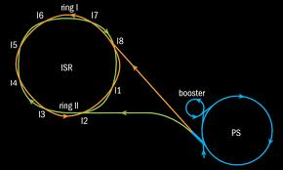
The ISR were the first hadron collider in the world (Figure 1). They consisted of two rings intersecting in 8 equidistant points at an angle of 15º. The circumference, 943 m, was chosen to be three halves of that of the CERN Proton Synchrotron (PS) that was used as an injector. Six of the intersections were used for physics, one for measuring the luminosity and one for dumping the beams. First protons were stored at 15 GeV on January 27th 1971. By May, the energy had reached 26.5 GeV and finally reached 31.4 GeV where most of the physics data were collected. Beam intensities increased from ~10 A in May 1971 to up to 57 A and the luminosity from 3 10²⁹cm²s^{–1} to 1.4 10³² cm²s^{–1} with low β insertions. Coasting times for physics reached 50 h. In addition to protons, deuterons, alpha particles and antiprotons had also been stored. The operation of the ISR turned out to be a remarkable success from the accelerator physics and technology point of view. Clearing electrodes and bake-outs (350º) of the stainless steel vacuum chamber made it possible to reach pressures as low as 10^{–11}Torr, which was essential to high luminosities. The machine has been an unprecedented laboratory for the study of proton beam dynamics, including that of transverse Schottky noise, which paved the way to Van der Meers’s stochastic cooling.
Figure 1. Schematic drawing of the ISR.
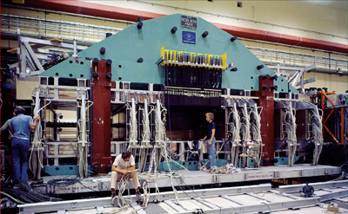
Most ISR experiments had been designed with the idea that all particles would be forward produced. It took a long time for detectors equipped with large angle calorimeters and magnetic fields, as required for the study of short distance (large transverse momentum, p_{T}) interactions, to be available. The Split Field Magnet (SFM) was a general facility on which much of the physics results have been obtained; the magnetic field was concentrated forward and negligible at large angles (Figure 2).
Figure 2. The Split Field Magnet.

2. The main milestones
Let us start with a brief reminder of the main events that marked the progress of our understanding of the strong interaction in the seventies. It started in 1968-1969 at SLAC [1] with the discovery of an important continuum in the deep inelastic region of electron-proton scattering. The 2-mile linear accelerator had started operation the preceding year and the experimental programme, using large spectrometers, extended over several years. From the very beginning, experimenters and theorists were in close contact, feeding each other with new data and new ideas, starting with Bjorken’s ideas on scaling [2] and Feynman’s ideas on partons [3], both early advocates of a proton structure consisting of point-like constituents. However, one had to wait until 1972 for the case for a quark model to become strong: by then, scaling had been established; the measurement of a small R value (the ratio of the absorption cross sections of transverse and longitudinal virtual photons) had eliminated competitors such as the then popular Vector Dominance Model; deuterium data had been collected allowing for a comparison between the proton and neutron structure functions; a number of sum rules had been tested; evidence for the quarks to carry but a part of the proton longitudinal momentum had been obtained; the first neutrino deep-inelastic data from Gargamelle had become available [4]. By the end of 1972, the way was paved for Gross, Wilczek and Politzer [5] to conceive the idea of asymptotic freedom and its corollary, infrared slavery, explaining why one could not see free quarks. By the end of 1973, the connection with non-abelian gauge theories had been established and the “advantages of the colour-octet gluon picture”, including the solution of the Fermi statistics puzzle, had been presented by Fritzsch, Gell-Mann and Leutwyler [6]. QCD was born and, by 1974, was starting to be accepted by the whole community as the theory of the strong interaction. It took another three to four years for it to come of age.
By mid 1972, SPEAR, the Stanford electron-positron collider, had begun operation. In November 1974, it shook the physics community with what has since been referred to as a Revolution: the discovery of the Ψ going hand in hand with the simultaneous discovery of the J at Brookhaven. It immediately exploited its ability to produce pure quark-antiquark final states to measure the number of colours. However, there were so many things happening in the newly available energy domain (opening of the naked charm channels, crowded charmonium spectroscopy, production of the τ lepton) that it took some time to disentangle their effects and to understand what was going on. By the end of the decade, scaling violations had been studied both in neutrino interactions and in electron-proton annihilations (DORIS had started operation in Hamburg two years after SPEAR). QCD had reached maturity and the only puzzling questions that remained unanswered, the absence of a CP violating phase and our inability to handle the theory at large distances, are still with us today.

3. Hadron production: universality of the main features
Out of the many early pictures of the dynamics of strong interactions, two passed successfully the ISR test: Van Hove’s Longitudinal Phase Space [7] and Feynman’s Partons [3].
Longitudinal Phase Space (LPS) states that at high energies hadrons are produced with limited transverse momenta (with a distribution that is essentially the Fourier transform of the proton disk, ħ/1 fm~220 MeV) and a uniform rapidity distribution (Figure 3). Partons suggest a field theory basis for such a picture, strong interactions proceeding via bremsstrahlung-like radiation of “wee” partons with no privileged frame of reference in the limit of infinite momenta. The nature of such partons was left unspecified in the original picture, but QCD would identify them with gluons later on.
p_{TTT}
y
2
1
Figure 3. LPS implies limited transverse momentum
(p_{T}) and uniform rapidity (y) distribution.
Remember that a Lorentz transformation of velocity β along Oz is a rotation by an angle iArgthβ in the (z, it) plane, simply shifting the rapidity (azimuth equivalent) by a constant: frame independence means uniform rapidity distribution and leads to Feynman’s scaling in the infinite momentum frame.
While the role of QCD basic vertices (qqg, ggg and gggg) is explicit in perturbative expansions (short distances, large p_{T}), it is hidden in the low p_{T} regime that prevails in hadron production: so-called “QCD inspired” models that have bloomed in the late seventies and early eighties have given a sound basis to the above picture but have not added much significant new information to it. Kinematics play an important role, dominated by the slow (lns) increase of the width of the rapidity plateau with energy (the bulk of the low p_{T} physics is often nicknamed “logs physics” for this reason). Also, to a good approximation, the dependence of the production cross-section on the mass (m) of the produced hadrons is simply described as a function of the transverse mass, m_{T}=√(p_{T}²+m²).
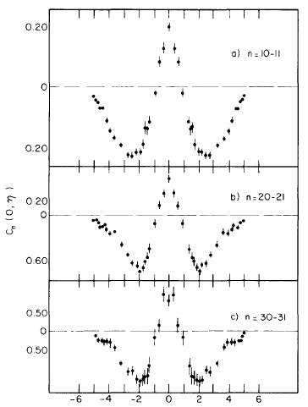
Such general features of the hadronization mechanism are observed to be universal (understood as essentially resulting from the radiation of gluons) with a flat rapidity plateau, limited p_{T}, short range correlations (Figure 4) and lns energy dependence. Such universality was demonstrated with clarity [8] by making explicit use of two essential concepts: effective energy and leading effect (Figure 5). The leading effect states that flavour (quark) quantum numbers are not radiated away and stay with the largest momentum hadron (the leader), a meson remaining a meson, and a baryon remaining a baryon. The effective energy is the energy available for hadronization after subtraction of that carried by the leader.
Figure 4. Short range rapidity correlations measured at the ISR [9] are displayed for different multiplicity bins. A simple cluster model gives a good description of the data.
In the early eighties, when the CERN proton-antiproton collider started operation, the validity of the above picture could be evidenced in its whole beauty [10] and studied in details.
Figure 5. While charged multiplicities measured at the ISR and electron-positron colliders display a universal dependence on effective energy, they differ from each other when the leading energy is not subtracted (lower line).

4. Large transverse momentum production
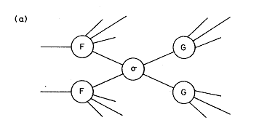
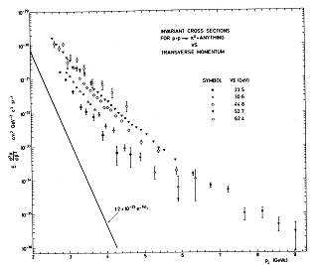
By 1972, the basic parton ideas had found their expression in the picture [11] of large transverse momentum production being factorized in three steps (Figure 6): singling out a parton in each proton (structure functions), making them interact (how? was not clear) in a binary collision and letting the final state partons fragment into hadrons (fragmentation functions). In 1972-1973, three ISR teams (Figure 7) announced the observation [12] of a copious pion yield at large p_{T}, orders of magnitude above the (traditionally called naïve) extrapolation of the exponential distribution observed at lower energies, ~exp(–6p_{T}). This first discovery opened the ISR to high p_{T} studies providing a new short distance probe. But many experiments had been designed under the assumption that most hadrons would be forward produced and were not matched to such studies: those having detectors at large angles were not covering a large enough solid angle; moreover, the background that had been anticipated in the search for new particles had been strongly underestimated and such searches were now becoming much more difficult than had been hoped for.
Figure 6. Parton model picture of high p_{T} hadron interactions. One parton of each of the incident hadrons (structure function F) experiences a binary collision (σ) and the outcoming partons fragment into hadrons (fragmentation function G).
Figure 7. Early inclusive π⁰ cross-section [12] giving evidence for copious production at high p_{T} well above the exponential extrapolation of lower energy data.
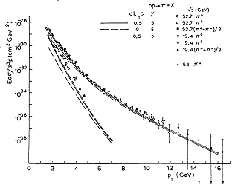
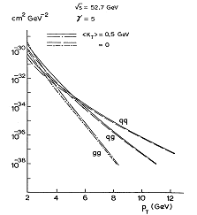
Bjorken scaling was soon found to apply, in support of the parton picture, but the index of the p_{T} power law was twice as high as the value expected from point-like constituents, 8 rather than 4. Precisely, the π⁰ inclusive invariant cross-section was of the form p_{T}^{–n}exp(–kx_{T}) where x_{T}=2p_{T}/√s, n=8.24±0.05 and k=26.1±0.5. The impact of this result was quite strong and brought into fashion the so-called constituent interchange model [13] that included mesons in addition to quarks among the parton constituents of protons. The model correctly predicted the power 8 measured at the ISR and had many successes but did not stand the competition with early QCD models that were starting to be developed. Such an example is illustrated in Figure 8, giving evidence for important quark-gluon and gluon-gluon contributions [14] beside the quark-quark term. It was soon understood that the p_{T} power law was indeed evolving to p_{T}^{–4} at high values of x_{T}, which, however, were only accessible, in practice, to larger centre of mass energy collisions. The successes of the constituent interchange models were then relegated to the rank of “higher twist corrections” to the leading order perturbative regime.
Figure 8. A typical QCD fit [14] to inclusive pion data (left) and the relative contributions of quark-quark, quark-gluon and gluon-gluon diagrams (right).
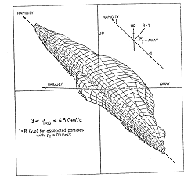
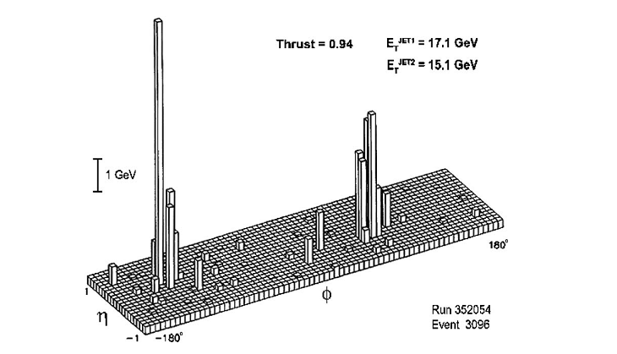
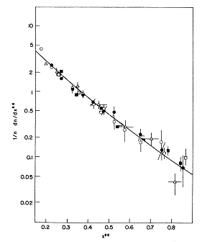
The early evidence in favour of the parton picture encouraged studies of the global event structure and, in particular, experiments aiming at the detection of the hadron jets into which the hard scattered partons were supposed to fragment. As none of the existing ISR experiments was matched to the task, some ISR collaborations decided to upgrade their detectors and, between 1973 and 1978, several of these studied the event structure: the evidence for hard jets in the final state, already clear in 1976, became very strong [15]. Diffraction was seen to be suppressed at large rapidities, a “same-side” jet is present alongside the trigger and “away-side jets”, at opposite azimuth to the trigger, cover a broad rapidity range (Figure 9). The presence of an “underlying event” implies a p_{T} threshold, ~1 GeV, below which a particle cannot be unambiguously identified as a fragment of a hard scattered parton. Single particle triggers distort the “same-side” jet fragmentation (trigger bias): an ideal experiment should trigger on the total transverse energy E_{T} using calorimeters.
Figure 9. Longitudinal phase space density (relative to minimum bias events) associated with a single particle trigger at 90⁰ (see text).
Figure 10. A lego plot from the AFS experiment showing two-jet dominance at larger E_{T}.

Figure 11. Jet fragmentation functions measured in different processes (DIS υ, triangles; ISR, circles; e⁺e–, solid line).

However, one had to wait until the eighties, with the Axial Field Spectrometer in I8 and the Superconducting Solenoid in I1 to see detectors having large calorimeter coverage. When the ISR closed down in 1984, a rich set of important results had been obtained by these two groups [16], with two-jet events dominating the scene (Figure 10) for transverse energies in excess of 35 GeV [17] but the CERN proton-antiproton collider, which had published its first jets in 1982, had already taken the limelight away from the ISR.
Away-jets were compared with quark jets observed in deep inelastic scattering and e⁺e– annihilations (Figure 11). The dominant feature is the universality of the hadronization process when expressed in terms of effective energy. However, ISR jets being mostly gluon jets, one could have expected them to have a higher multiplicity than quark jets of the same effective energy, as a result of their higher colour charge. But the difference is small and the p_{T} range accessible to the ISR was too low: one had to wait for LEP and the proton-antiproton colliders to see it.

Table 1. Leading order processes involving quarks or gluons.
We use the symbol >< for s channel and ][ for t channel exchanges. Leading order contributions are shown as bold. Diagram involving the ggg or gggg vertices are shown in italic. Next to leading order contributions (scaling violations) involve only the qqg vertex and are shown in normal font.

e+e– annihilations | e+e–>γ<q+q– e+e–>γ<q+q–g
DIS (electron) | eq]γ[eq eq]γ[eqg
DIS (neutrino, NC) | νq]Z[νq νq]Z[νqg
DIS (neutrino, CC) | νq]W[lq νq]W[lqg
pp Drell Yan | q+q–>γ<l+l–
pp Direct photons | q+q–]q[γg qg]q[γq
pp Large pT hadrons | qq]g[qq qq]q[gg  q+q–>g<gg q+q–>g<q+q–  qg]q[qg qg]g[qg  qg>q<qg gg>g<q+q–  gg>g<gg gg]g[gg  gg]q[q+q– gg><gg

It is important to recognize the role, in the large transverse momentum sector, played by the ISR as an exclusive gluon collider. In this sector, where perturbative QCD applies, gluons contribute to leading order (Table 1). In e⁺e– annihilations and deep inelastic scattering, they contribute to next to leading order only, in the form of radiative corrections associated with a bremsstrahlung gluon radiated from a quark. This does not mean that such gluon contributions are unimportant: the scaling violations which they induce have been one of the most powerful tool in the development of our understanding of QCD. But, at the ISR, gluons dominate the scene: in this low x_{T} regime, collisions involving gluons, either g-g or q-g, account for most of the high p_{T} cross-section. Gluon interactions being the privileged domain of the ISR, and gluons having been the last component of the theory to be understood and digested, the ISR have played a major role in probing this essential QCD sector. In particular the ISR had exclusive access to the three and four gluon vertices, which are a specific expression of QCD as a non abelian gauge theory.
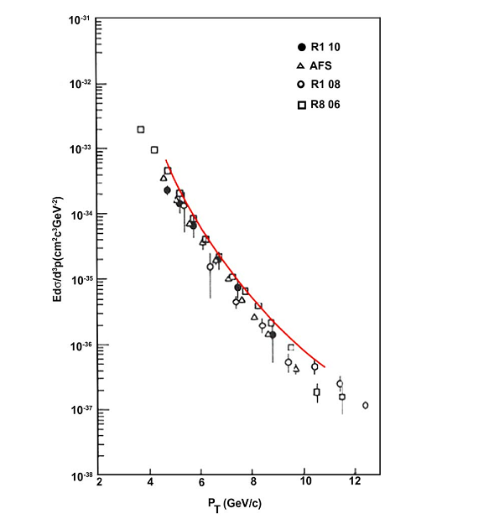
Finally, by the end of the seventies, the J/Ψ and the Υ had been detected and their production cross-sections had been measured. Clear evidence for D production had been obtained – for the first time in hadron interactions [18]. Dilepton masses up to 20 GeV have been ultimately studied, giving evidence for strong next to leading order corrections to the Drell-Yan leading order diagram. The ISR were a privileged laboratory for the study of direct photon production [19], which proceeds mainly by Compton interaction between a quark and a gluon producing a quark and a photon.
Figure 12. Direct photons at the ISR.

5. Total cross-section and elastic scattering
The rise of the total cross-section with energy was measured early at the ISR and came to many as a surprise [20]: it was generally believed that it should reach asymptotia. Seen as a diffraction process, elastic scattering gives the shape of the absorbing area globally associated with the total cross-section. Both σ_{tot} and dσ/dt|_{t=0} (Coulomb interference region) were measured to obtain the scattering amplitude F(s,t) near t=0. The following relations apply: Im(F(s,0)=sσ_{tot}(s) 16πs²dσ/dt=|F(s,t)|²
σ_{tot}²=16π s²dσ/dt|_{t=0} /(1+ρ²) where ρ(s)=Re(F(s,0))/Im(F(s,0)).
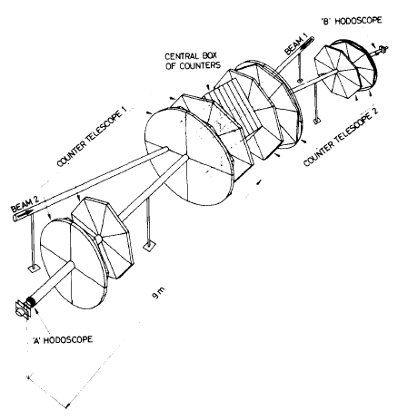
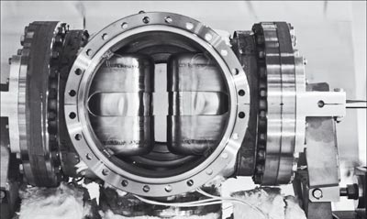
Figure 13. Total cross-section schematic layout (left) and a “Roman pot” (right) used for the measurement of the elastic cross section in the Coulomb interference region.

The measurement of the elastic cross-section in the interference region required detectors approaching the beam far closer than allowed by a standard vacuum chamber. This was achieved by inserting them in remote-controlled bellows, the so-called “Roman pots”, named after the CERN-Rome group who invented them. The trends measured at the ISR (Figure 14) were later on found to continue in the proton-antiproton and LHC energy ranges, confirming the inadequacy of a naïve diffractive picture implying a total cross-section independent of energy.
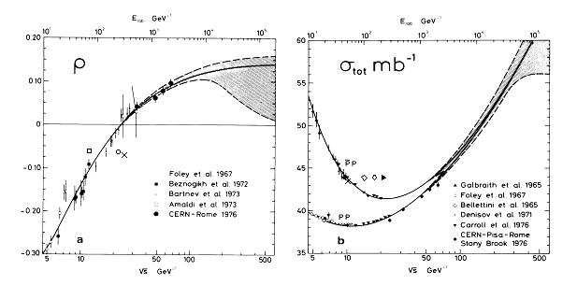
Figure 14. Energy dependence of the total cross-section (right) and of the ρ parameter (left).

6. Conclusion
Most of the ideas we have today of the strong interaction date from ISR times.
6. Conclusions
The dominant features of the strong interaction revealed at the ISR are still with us today, comforted but not deeply affected by QCD. The proton-antiproton and LEP colliders have made them evident and exposed them in full beauty.
They include at large distances: lns dependence on energy, limited p_{T}, uniform rapidity plateau, short range rapidity correlations, transverse mass unification, and at short distances: jet production, factorization of the structure and fragmentation functions as well as of the underlying event. Their universality is made explicit by using the concept of effective energy that takes in due account the leading particle effect.
At the ISR, the complexity of the physics processes at stake, much larger than at e⁺e– colliders, made it difficult to devise decisive QCD tests independent from what had been learned at other accelerators. But ISR data have explored elementary processes which were not accessible to other accelerators and were found to nicely fit in a coherent QCD picture embedding deep inelastic scattering as well as e⁺e– annihilation results. This was clearly an independent and essential contribution but the fact that they always validated QCD predictions made the superficial observer underestimate their importance. This lack of recognition was also caused by the lack, for many years, of detectors optimized for the study of hard processes, the absence of the weak sector from the ISR landscape and the fact that hard hadron collisions imply complex processes which may seem “dirty” to whom does not make the effort to study them in detail.
We, who worked at the ISR, tend not to attach much importance to this relative lack of recognition: for us, their main legacy has been to have taught us how to make optimal use of the proton-antiproton colliders, which were soon to come up. They had given us a vision of the new physics and of the methods to be used for its study which turned out to be extremely profitable. They had played a seminal role in the conception of the proton-antiproton colliders experiments, they were the first hadron collider ever built in the world and they were the machine where a generation of engineers and physicists learned how to design colliders and collider experiments. We see ISR and proton-antiproton colliders as a lineage, father and sons, the success of the latter being inseparable from the achievements of the former.
We were young then, we remember these times with emotion… With the LHC, the lineage has now extended to a third generation and we look at the future with the eyes of grand parents, full of tenderness and admiration for their grand son, whom we wish fame and glory.

Acknowledgements
It is a pleasure to thank Professor Antonino Zichichi and the organizers of the Colloquium for having invited me to give this brief recollection. I am deeply grateful to Luigi Di Lella for pertinent comments on the manuscript.

References
General reviews, such as those listed below, are an important source of references:
Giorgio M. Giacomelli and Maurice Jacob, Physics at the CERN-ISR, Phys. Rep. 55 (1979) 1.
Leon van Hove and Maurice Jacob, Highlights of 25 Years of Physics at CERN, Phys. Rep. 62 (1980) 1.
Maurice Jacob, in : A review of Accelerator and Particle Physics at the CERN Intersecting Storage Rings, CERN 64-13 (1984) 21-81.
U.Amaldi, P.Bryant, P.Darriulat, K.Hübner, Colloquium on the 40th Anniversary of the First Proton-Proton Collisions in the ISR, forthcoming CERN Report.

1. Jerome I. Friedman, Deep Inelastic Scattering Evidence for the Reality of Quarks, History of Original Ideas and Basic Discoveries in Particle Physics, H. B. Newman and T. Ypsilantis editors, NATO ASI series, B352 (1994) 725 and references therein.
2. James D. Bjorken, private communication to the MIT-SLAC group, 1968, and Phys. Rev. 179 (1969) 1547.
3. Richard P. Feynman, Phys. Rev. Lett. 23 (1969) 1415; Proceedings of the IIIrd International Conference on High Energy Collisions, Gordon and Breach, new York, 1969.
4. Donald H. Perkins, in Proceedings of the XVIth International Conference on High Energy Physics, Chicago and NAL, vol. 4 (1972) 189.
5. David J. Gross and Frank Wilczek, Phys. Rev. Lett. 30 (1973) 1343; Phys. Rev. D8 (1973) 3633 and Phys. Rev. D9 (1974) 980.
6. H. Fritzsch, Murray Gell-Mann and H. Leutwyler, Phys. Lett. 47B (1973) 368.
10. Alvaro De Rujula, QCD in “her” Maiden Years, History of Original Ideas and Basic Discoveries in Particle Physics, H. B. Newman and T. Ypsilantis editors, NATO ASI series, B352 (1994)123.
7. Leon Van Hove, Nucl. Phys. B9 (1969) 331.
8. V.N. Gribov, G. ‘t Hooft, G, Veneziano and V.F, Weisskopf , The Creation of Quantum Chromodynamics and the Effective Energy, World Scientific Series in 20th CenturyPhysics, Vol. 25, edited by L.N. Lipatov.
9. Lorenzo Foa, Phys. Rep. 22 (1975) 1 and references therein.
10 G.J. Alner et al. (UA5 Collaboration), Phys. Rep. 154/5-6 (1987) 247.
11. M. Berman and M. Jacob, Phys. Rev. Lett. 25 (1970) 1683; J.D. Bjorken and E.A. Paschos, Phys. Rev. 185 (1968) 1975; S.D. Drell, D.J. Levy and T.M. Yan, Phys. Rev. 187 (1969) 2159; S.M. Berman, J.D. Bjorken and J. Kogut, Phys. Rev. D4 (1971) 3388; J. Kuti and V.F. Weisskopf, Phys. Rev. D4 (1971) 3418; S.D. Drell and T.M. Yan, Phys. Rev. Lett. 25 (1970) 316.
12. B. Alper et al., Phys. Lett. B44 (1973) 521 ; M. Banner et al., Phys. Lett. B44 (1973); 537; F.W. Büsser et al., Phys. Lett. B46 (1973) 471 and Proc. 16th Int. Conf. on High Energy Phys. (Chicago and NAL, 1972).
13. D. Sivers, R. Blankenbecler and S.J. Brodsky, Phys. Rep. C23 (1976)1 and references therein.
14. A.P. Contogouris, R. Gaskell and S. Papadopoulos, Phys. Rev. D17 (1978) 2314.
15. Pierre Darriulat, Proc. XVIIIth Int. Conf. on High En. Phys., Tbilisi, USSR, 1976, N.N. Bogolioubov et al. editors, JINR Dubna, 1977; Large Transverse Momentum Hadronic Processes, Ann. Rev. Nucl. Part. Sci. 30 (1980) 159 and references therein..
16. T. Åkesson et al., Phys. Lett. B118 (1982) 185 and 193; Phys. Lett. B123 (1983) 133; Phys. Lett. B128 (1983) 354; Z. Phys. C25 (1984)13; Z. Phys. C30 (1986) 27; Z. Phys. C32 (1986) 317; Z. Phys. C34 (1987) 163; A.L.S. Angelis et al., Phys. Lett. B126 (1983) 132; Nucl. Phys. B244 (1984) 1; Nucl. Phys. B303 (1988) 569. 21.
17. ChristianW. Fabjan and Norman McCubbin, Physics athe CERN Intersecting Storage Rings (ISR) 1978-1983, Phys. Rep. 403-404 (2004) 165-175.
18. Daniel Drijard et al., Phys. Lett. B81 (1979) 250 and B85 (1979) 452.
19. M. Diakonou et al., Phys. Lett. B87 (1979) 292 ; A.L.S. Angelis et al., Phys. Lett. B94 (1980) 106; T. Ferbel and W.M. Molzon, Rev. Mod. Phys. 56 (1984) 181; L.F. Owens, Rev. Mod. Phys. 59 (1987) 485; P. Aurenche et al., Nucl. Phys. B297 (1988) 661 and Eur. Phys. C9 (1999) 107.
20. Ugo Amaldi et al., Phys. Lett. B 44 (1973) 112, Phys. Lett. B 62 (1976) 460, Phys. Lett. B 66 (1976) 390 and Nucl. Phys. B145 (1978) 367.
S.R. Amendolia et al., Phys. Lett. B44 (1973) 119.

